**GIT AND GIT HUB ASSIGNMENT**

1. CREATE A GIT HUB ACCOUTNT

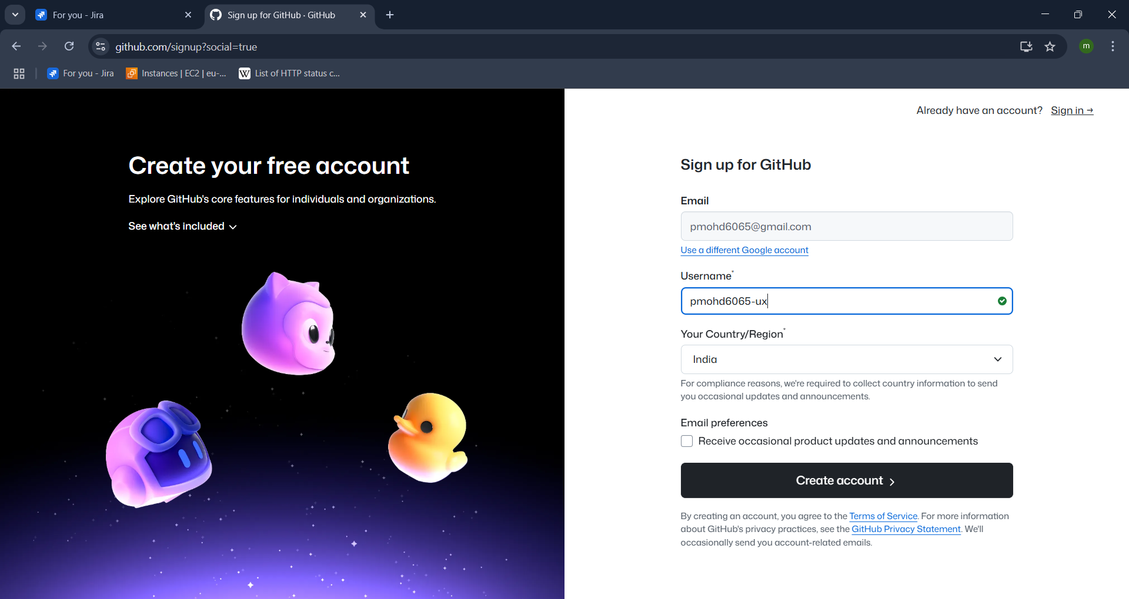

* Go to the web browser and search git hub
* Click on git hub portal and click on sign up
* Create the account
* Enter the details required and click on create account

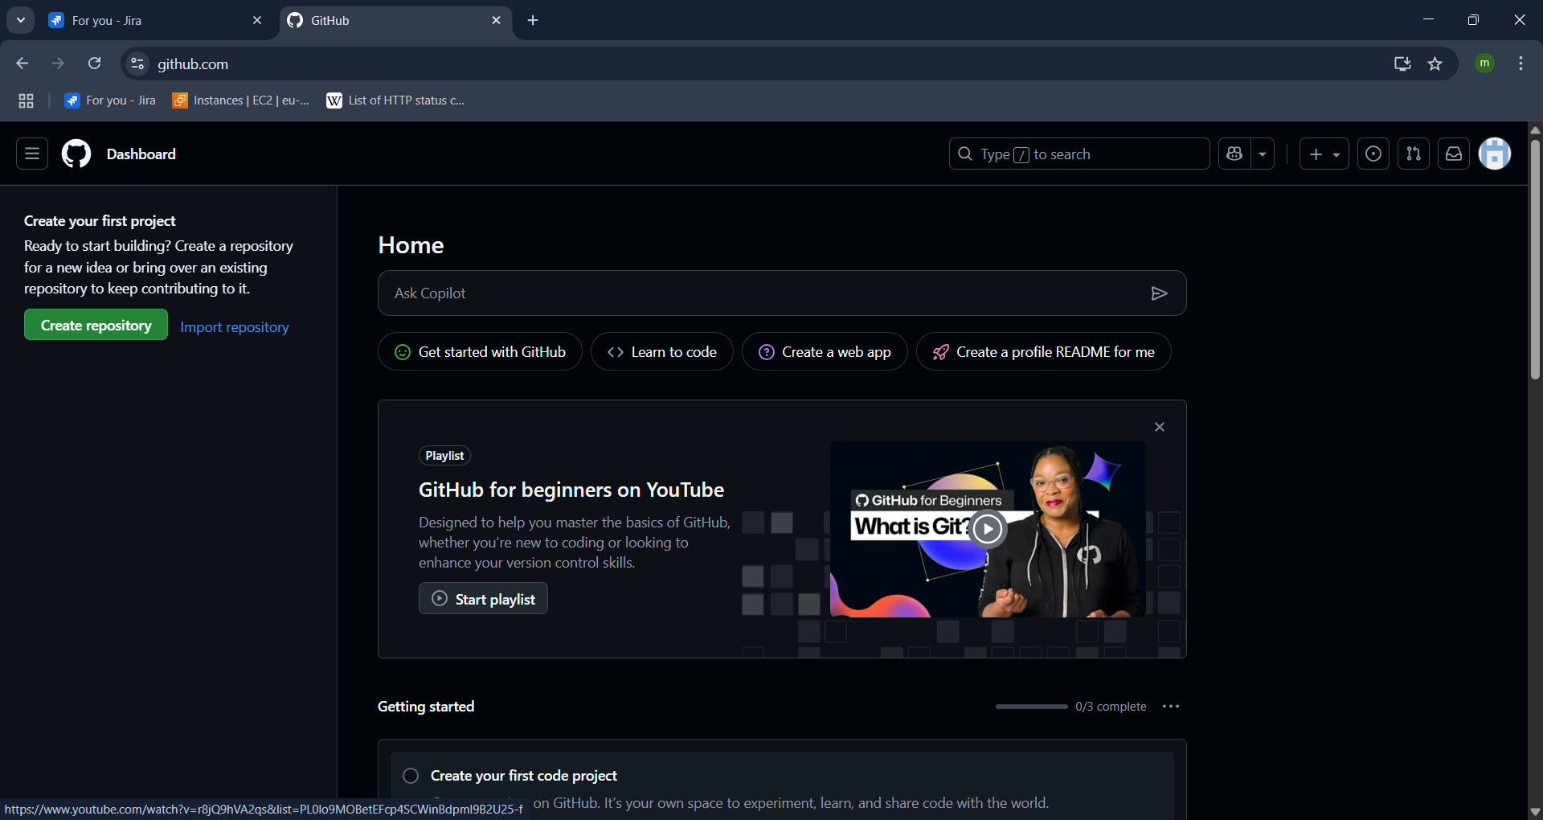

* You can see the acoount has created and redirected to the page.

1. SET UP MFA FOR GIT HUB USING MOBILE APP

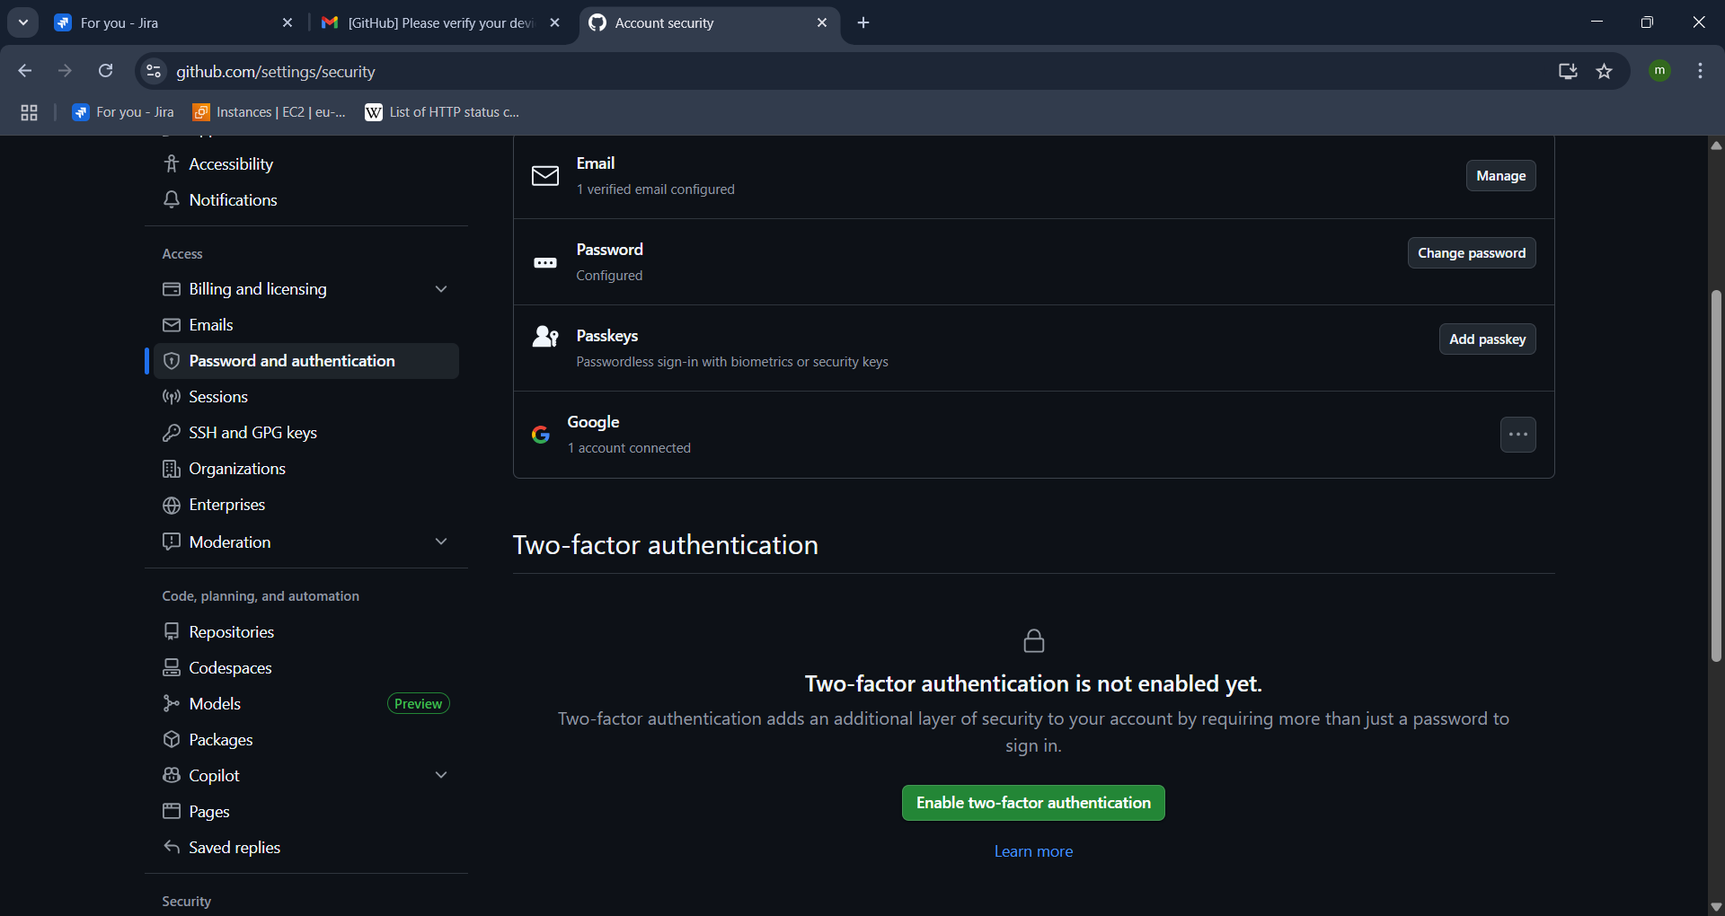



* for two factor authentication got to git hub settings



* Then go to password and authentication
* Click on enable two -factor authentication

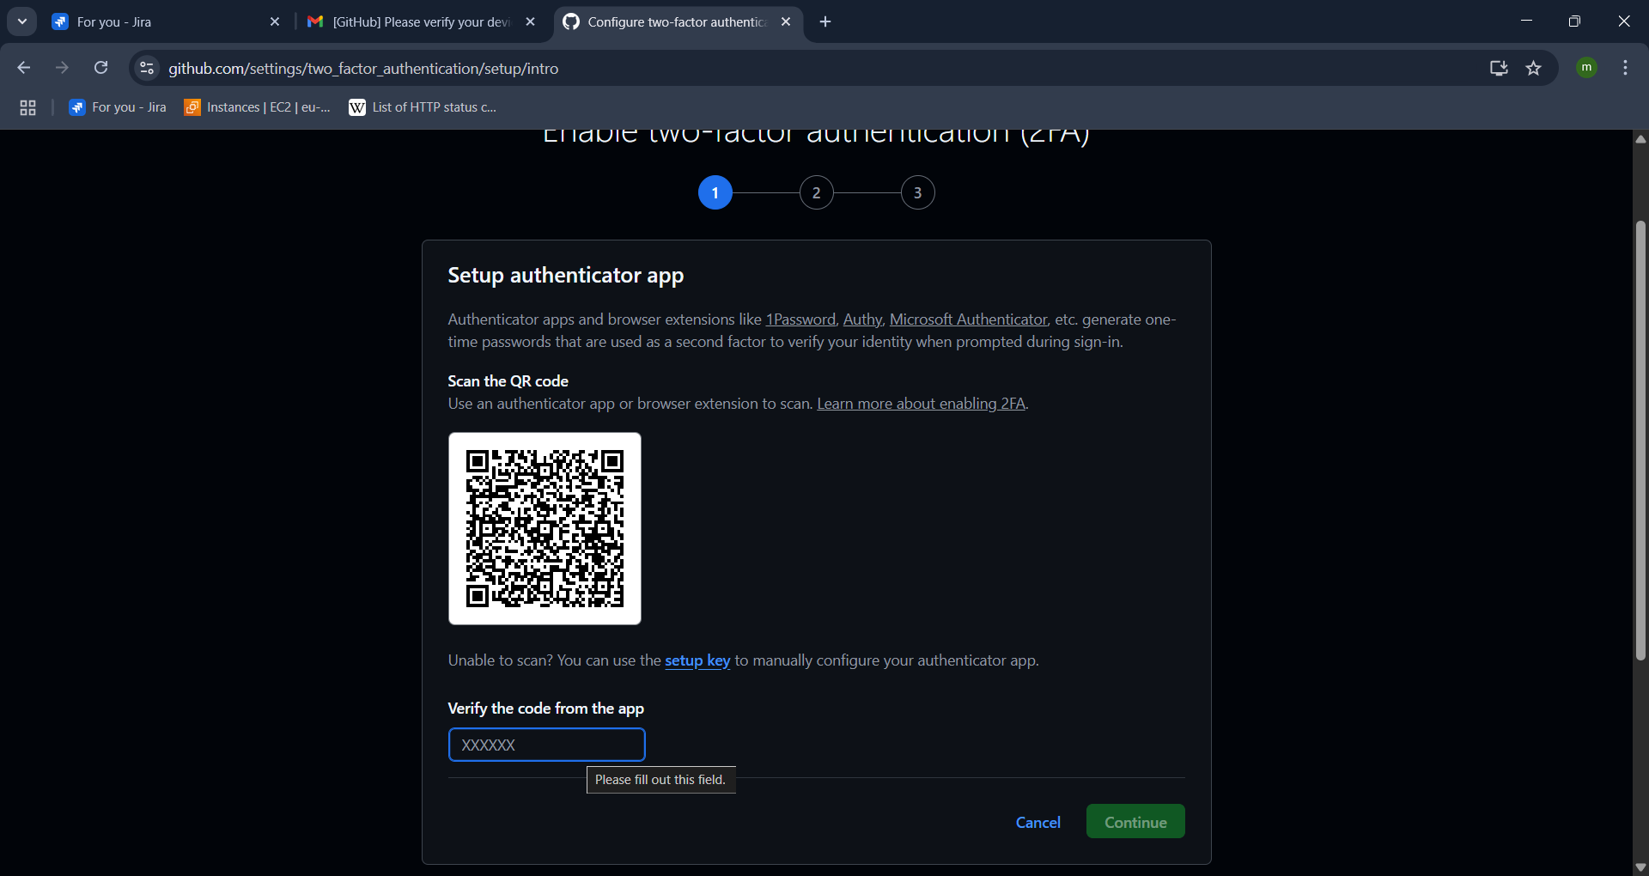

* Scan qr code from Microsoft authenticator app from mobile
* Enter the code shown
* Download the recovery codes file for recovery
* Save it then the 2 factor authentication mobile is done if you want uou can also add your phone number to verify.
* Authentication completed.

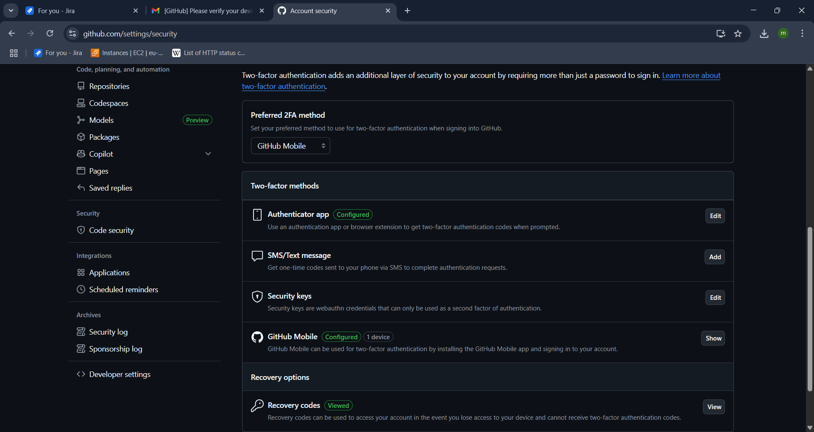

1. EXECUTE COMMANDS SHOWN IN THE VIDEO

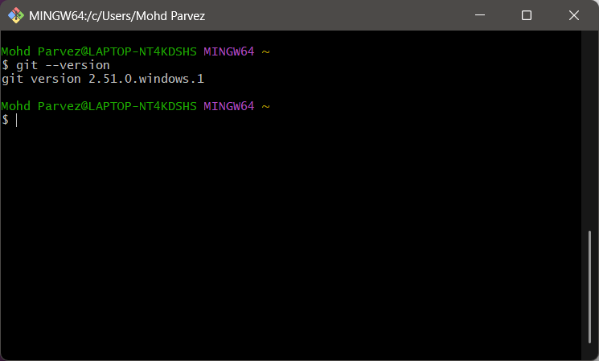

* Git --version : check the version of the git
* Create the directory : mkdir hiring-app
* Go to the directory : cd hirirngapp

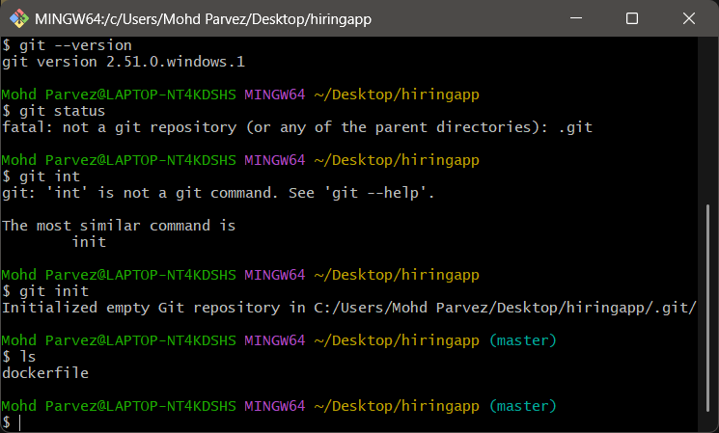

* Git init : It initializes a new Git repository in your current directory, allowing you to start tracking changes to files.

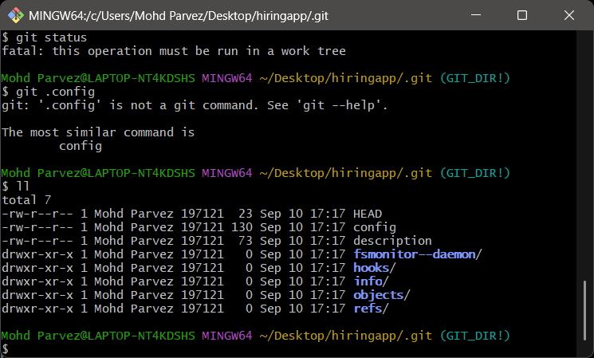

* .git : this directory contains all configuration related to git what is branch what is tail to track the changes the git will not work without this directoey.
* 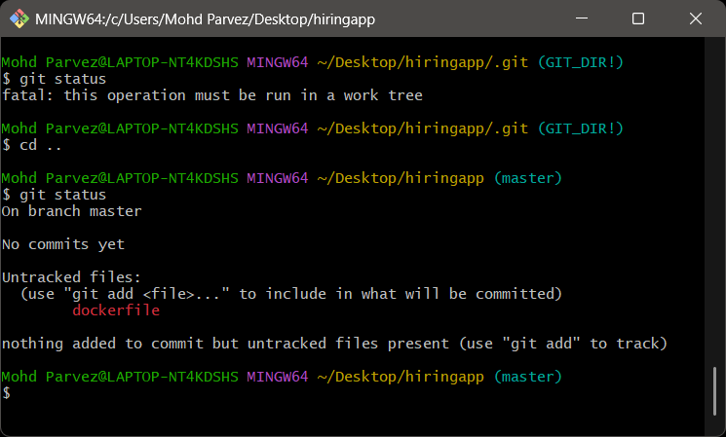git status: check the status of file is tracked or not

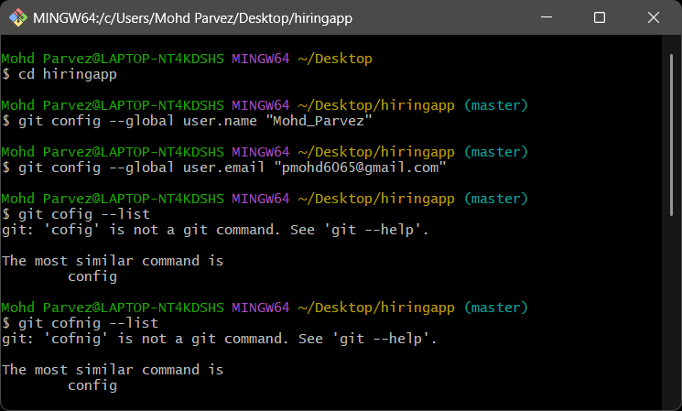

* Git config --global user.name “Mohd_Parvez” : to add the user name
* Git config --global user.email “pmohd6065@gmail.com” : to add the gmail

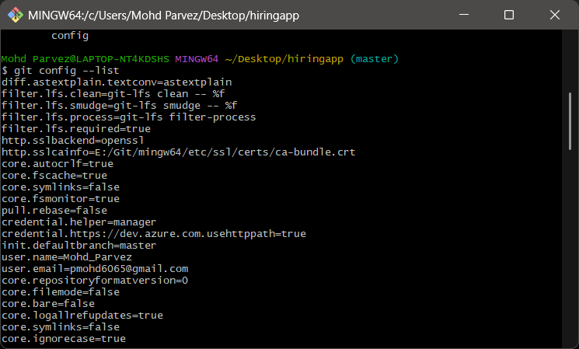

* Git config - -list to see te configuration of the git
* You can also see your user name and email you provided.

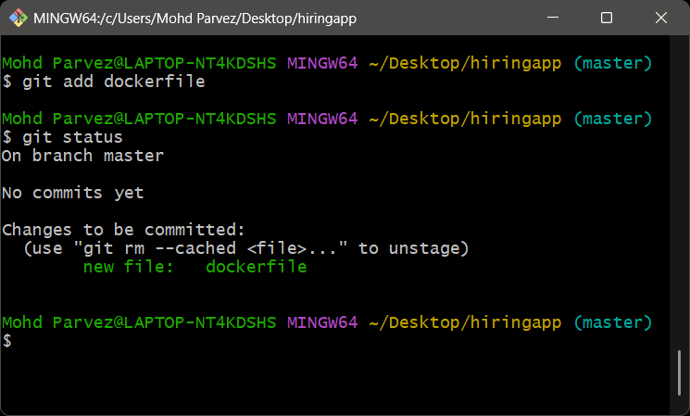

* Git add “file name” :to add the file
* Git status : you can see the new file has been added to the master origin

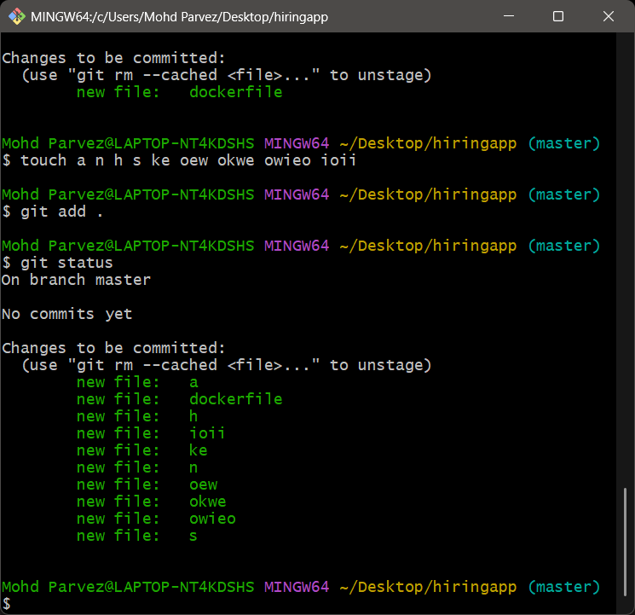

* Touch “file names with spaces” : create multiple files
* Git add . ; to add multiple files to the git.

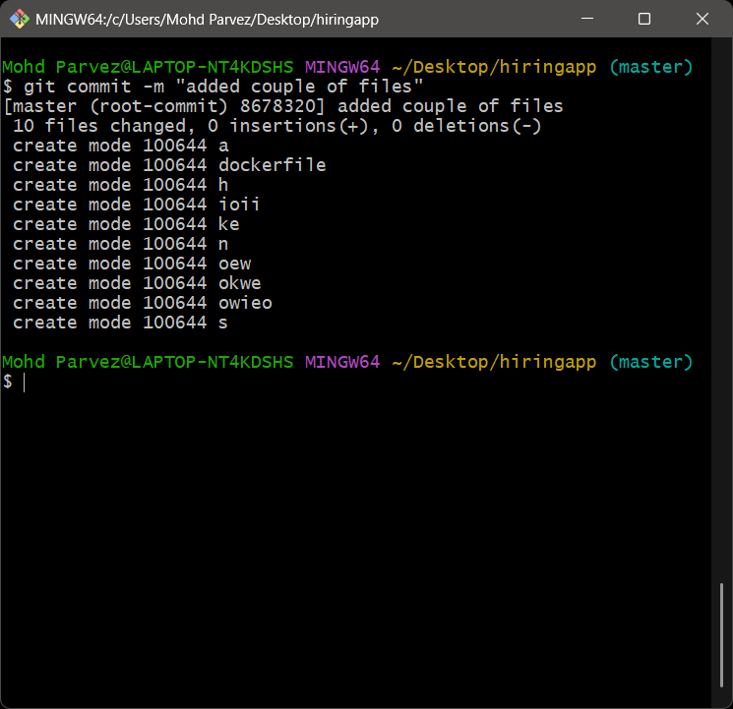

* Git commit -m “messege” – store a copy in machine and provide messege what you have done.

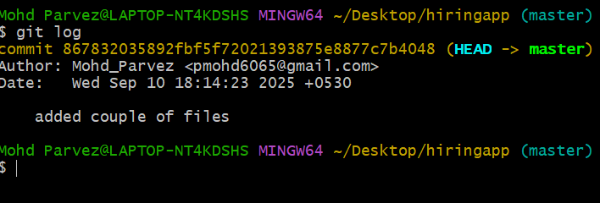

* Git log : print all the logs you have made the changes with commit id and commit messege ,username , user email, date & time.
* For every commit there will be commit id generated
* Commit id you can revert the changes with it

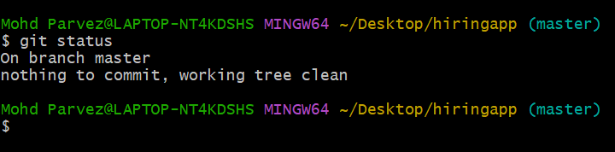

* Git status ; you see the working tree clean nothing to commit means there no other changes to be commited.

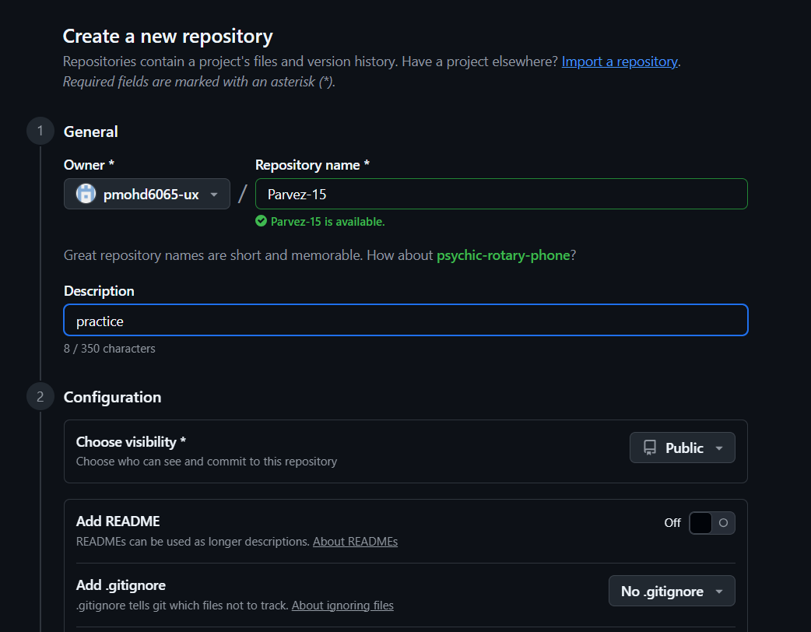

* Go to git hub create new repository to push all the files to repository.

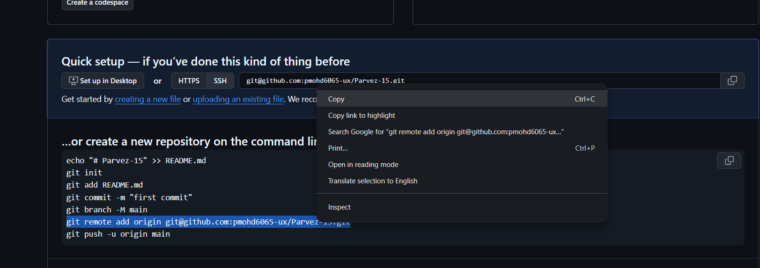

* Copy the url to remote access the repositotry

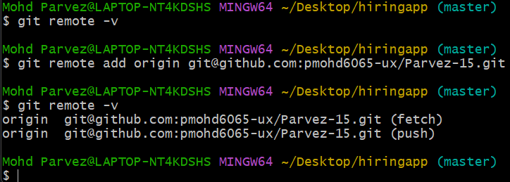

* Git remote -v : it shows if any address has been configured we can see.
* Gir remote add origin “url” : to get remote access to the central repository.

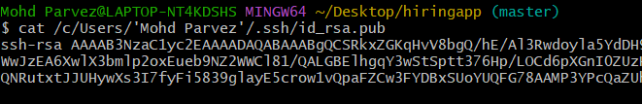

* Ssh-keygen -t rsa: key generation
* Cat “path/to/keygen” : to view key
* 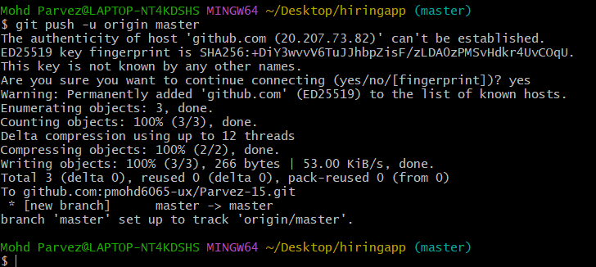copy the key and ad it in git hub
* Git push -u origin master : to push the files to the central repository

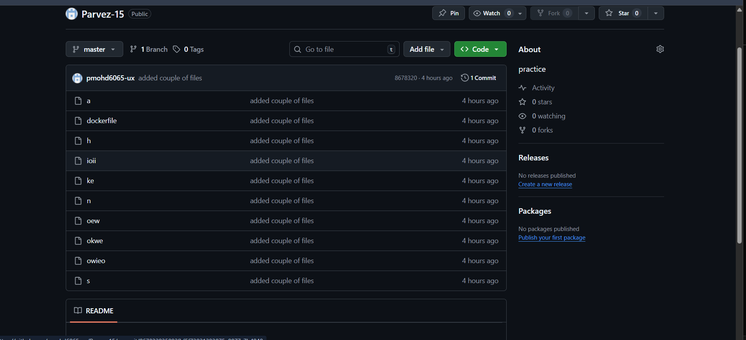

* Now you can see the files has been syced to the repository.

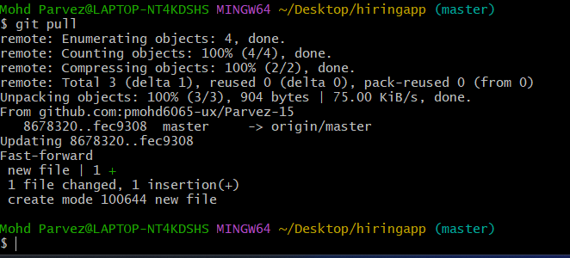

* Git pull : to sync the files from repository to the local machine if any files has been adde directly from the repository
* The “git push” will get error if you add files directly from repository and to not get any issues you need to pull the files from repository to maintain the sycronisation.